Please pass this on to any woman you know...

A new scam is being pulled on women mainly in broad daylight.

What happens is that when the intended victim stops at a traffic light, an almost NUDE, good looking, tanned, muscled young man comes up to her car and pretends to wash the windshield….

While he is doing this, another young, handsome athletic man opens the back door of the car, jumps in and insists the woman drive off with him to some lonely spot, where he has his way with her….

They are very good at this…

They got me three times Friday and five times Saturday..

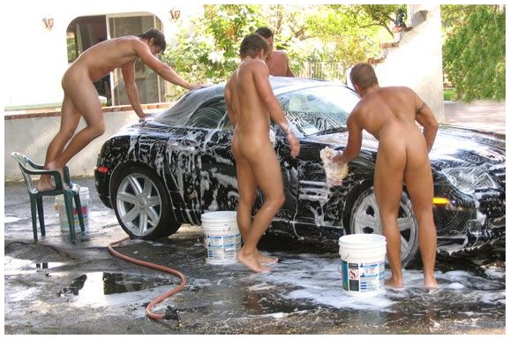

....................I couldn't find them on Sunday.

