This Is The Old Hong Kong Airport - Once Considered The Most dangerous Airport In The World.
Ever Wonder Why They Built A New One????
Photos # 1 and # 2 were taken from the high rise balconies.
No autopilot stuff here...hand fly that sucker, and don't screw up...!!!
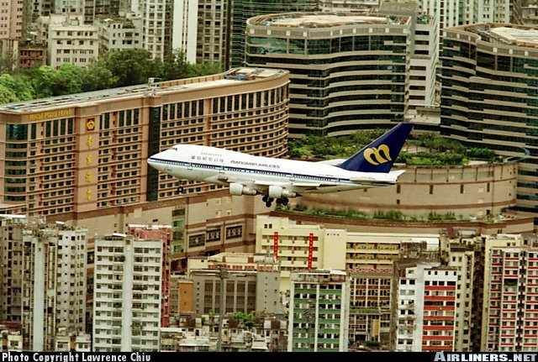
The prayer : "Lord, if I'm gonna die...please don't let it be pilot error"
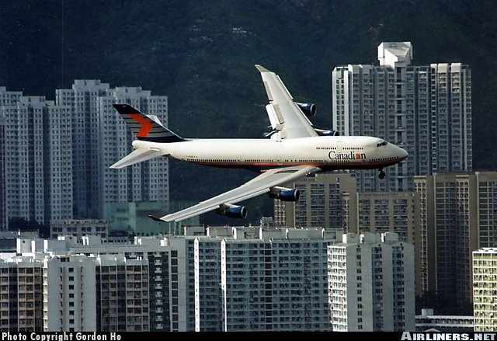
At ILS "Minimums"...you break out of the clouds at the top of a hill..!!! First one to see it calls "Checkerboard in sight"...!!
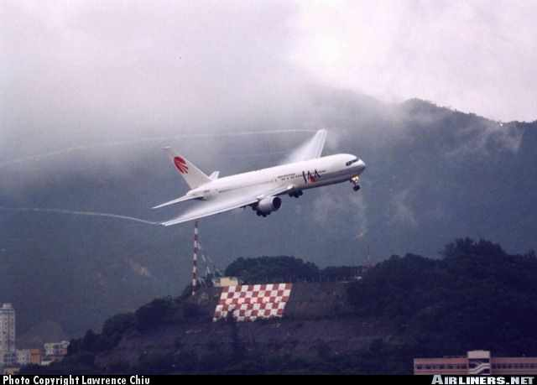

Now...hard right turn and dive !!!...and don't mess around, or you simply won't make it..!! Is that a short runway or what...!!
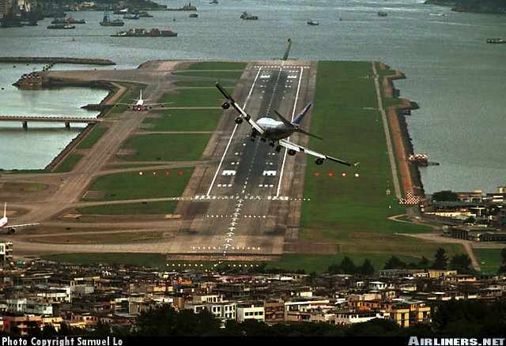

Woe to you if you're too high...!!!
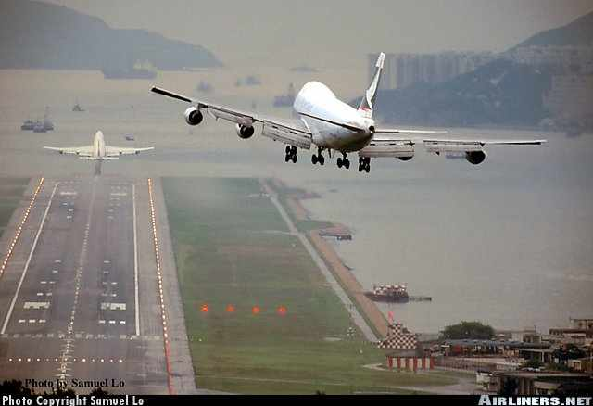

Strong cross winds were common...so you had to "crab" all the way to the runway...!!!
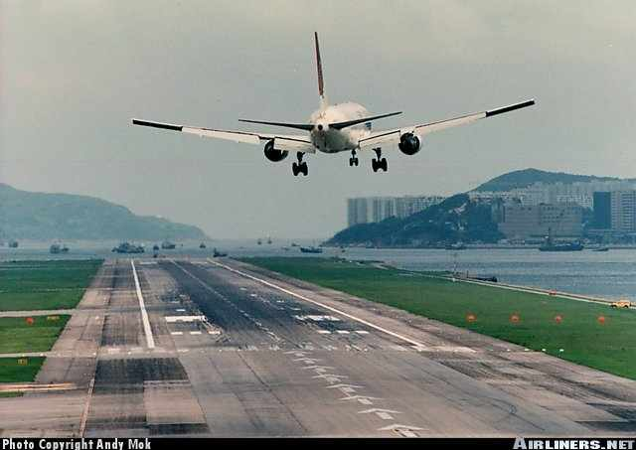
Sometimes the cross-winds were stronger than others..
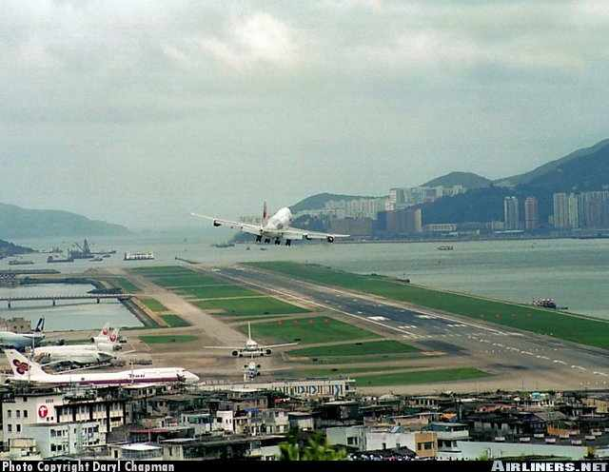
Over shoot, and you're in the drink...kick it out of the crab too soon, and you're blown back off the runway...wait too late and "crunch"...# 4 engine..!!!
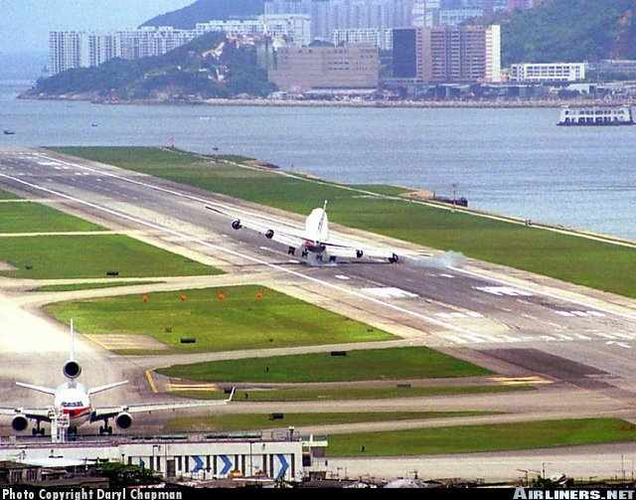
Overreact on the crab correction, and "Crunch" # 1 engine...!!!
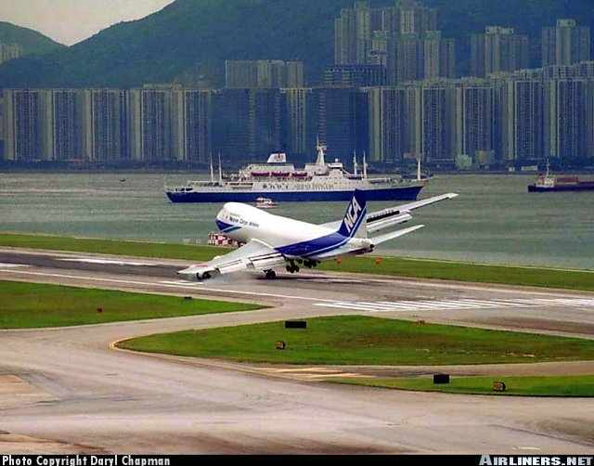

Don't "Float" or try to make a smooth landing...Just put it on...!!! "Firm" landings help dissipate energy, and help you stop...!!!
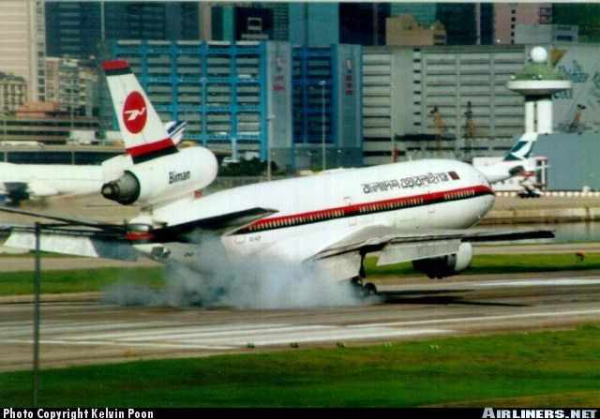
Drop too low, and you'll drag your wheels thru the high rises...!!!
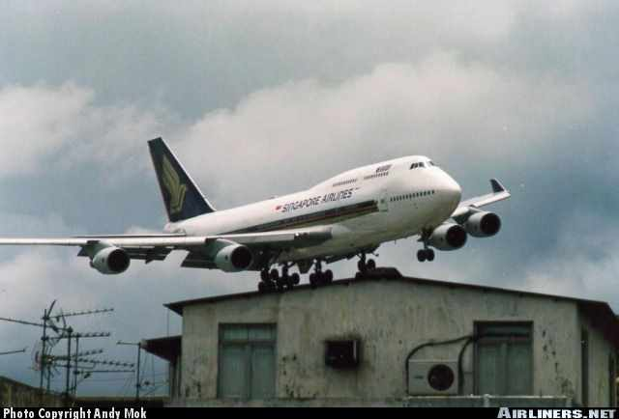

What I said was: "I think we're a little high and fast... nice smooth touchdown though, Sir !µ


