MEMORANDUM
Date: October 4, 2005
Re: Mandatory Office Equipment (MOE)
Effective immediately, all employees will be required to maintain in their workplace the following mandatory office equipment, (“MOE”) and shall become familiar with its proper use.

The intent is to relieve stress, promote a friendly work environment and assist employees in generally coping with their co-workers and supervisors.
All employees are to keep with them MOE consisting of two (2) paperclips and two (2) elastic bands. See Figure 1 below. If you do not already have access to this equipment, please get it from the supply cabinet. All MOE shall be assembled and kept ready as shown in Figure 2.
Fig 1: MOE - Paperclips and Elastic Bands.
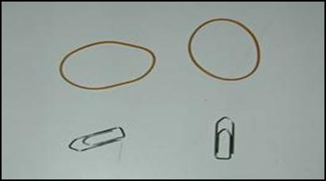

Fig 2: MOE Assembly. 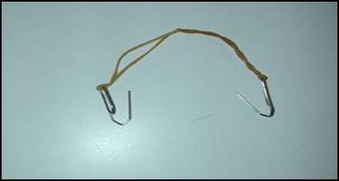
Whenever an employee deems it necessary, or if your supervisor drops off a ton of work on your desk at 4:45 pm on a Friday, place MOE on head as illustrated in Figure 3.

Fig 3: Proper MOE application


We hope that this will help you and promote a friendlier work environment.

