Subject: THE NEW BATHING SUIT FOR MEN- ---------Adult
NOW TELL ME, COULD YOU SEE YOUR MAN IN THIS????????
Can you believe it? This was spotted on the beaches of Calif.


Sexy

Hubba Hubba

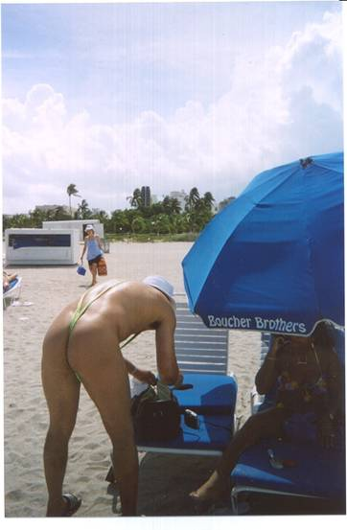
Rear View

Send this on to the guys in your life. They'll want to run out and purchase one soon!!
(And don't forget the ladies too, they need a laugh!!)

